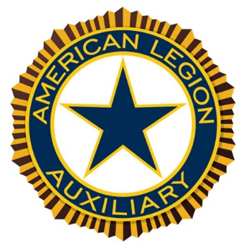

Preamble

Preamble to the American Legion Auxiliary’s Constitution and By-laws:

For God and Country, we associate ourselves together for the following purposes:

To uphold and defend the constitution of the United States of America; to maintain law and order;

To foster and perpetuate a one hundred per cent Americanism;

To preserve the memories and incidents of our associations during all wars;

To inculcate a sense of individual obligation to the community, state and nation;

To combat the autocracy of both the classes and the masses; to make right the master of might;

To promote peace and goodwill on earth; to safeguard and transmit to posterity the principles of justice, freedom, and democracy;

To participate in and contribute to the accomplishment of the aims and purposes of The American Legion;

To consecrate and sanctify our association by our devotion to mutual helpfulness.

Greetings from Third District President
Ann Bovy

Welcome to the Third District Convention. I am looking forward to meeting and visiting with everyone. I want to thank Post/Unit 45 New Prague for all the hard work and dedication needed to set up and host this convention.
Thank you everyone for coming, it is wonderful to have you all here. If this is your first time attending the Third District Convention, I hope you enjoy the convention and meet new friends from other units. Not only is this a great opportunity for our Legion Family to be together, enjoy each other’s company and to have the opportunity to take home important information to our units about what we did at convention, we also will be having elections for the new District Officers for 2026/2027 which you will be able to take part in.
We will be celebrating our hard work through the year of creativity, past accomplishments, and set the course for our future.
Thank you to all the members for your continued support throughout the year for our veterans, military families, our youth and communities and thank you to all the District Chairmen and Special appointments for going the extra mile for the District.
I hope that you all have a safe trip home and a healthy year.
Ann Bovy
Third District Auxiliary President
2025-2026

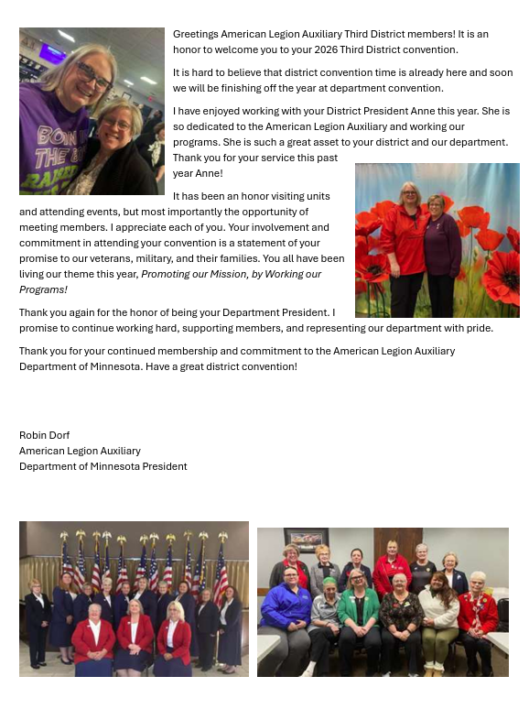

2026 THIRD DISTRICT
AMERICAN LEGION AUXILIARY CONVENTION PROGRAM

Friday, May 15, 2026
1:30 pm Executive Committee Meeting - American Legion Post 45
4 – 7:00 pm Registration - American Legion Post 45
5:00 pm Past Commander/Adjutant/ Past President/Secretary and SAL Officers banquet,

Saturday, May 16, 2026

7:00 – 11:00 Registration – Post 45
8:00 Joint Opening session
9:00 Individual session
Introduction of 3rd Dist. Officers - President Ann Bovy
Introduction of Special Appointments to Convention
Preliminary Report of the Credentials Committee
Report from the Convention Rules Committee
Reading of Call to Convention Dist. Secretary, Karla Otterness
Minutes. of 2025 Dist. Convention, Dist. Secretary, Karla Otterness
Report from the Resolutions Committee
Report from the Standing Rules Committee
Roll Call of Units – President, Ann Bovy
Presentation of Convention’s Distinguished Guests
Report from the Nominating Committee Michelle Leonard
Candidates for Elections of Officers
Announcements – District Secretary, Karla Otterness
10:45 Dismiss for joint Memorial Service.
11:00 Joint Memorial Service at Post 45
12:00 Voting begins.
12:00 am Recess for lunch After Memorial Service

1:00pm Call to Order – President Ann Bovy
Voting ends
Presentation of Distinguished Guest
Roll Call of Units (Continued)
District Treasurer’s Report – Teri Richardson
Recognition of Auditing Committee
Third District Chairmen Reports & Presentation of Awards
Recognition of Special Convention Appointments
Final report of the Credentials Committee
Courtesy Resolutions
Presentation of the Third District Past Presidents

Auxiliary Member of the Year Award presentation

Election for 2026-2027 Third District Officers
Election of Delegates and Alternates to National Convention
First Vice President Cavalene Regan
District President’s final Report – Ann Bovy
Final Report by the Standing Rules Committee -
Announcements – District Secretary, Karla Otterness
Benediction Tamara Thayer-
Retirement of Colors – District Sgt.-at-Arms, Diane Mackenthun

Adjournment – President, Ann Bovy

the 2026/2027 officers will meet immediately after convention. Location to be announced.

2026/2027 Third District Officer Nominations

President
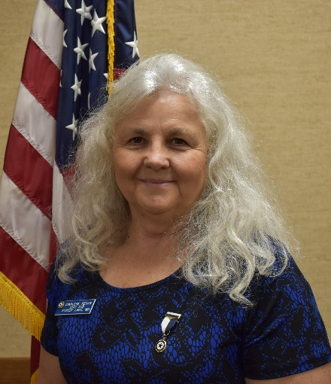
We are writing to endorse Cavalene Regan for the position of President of the American Legion Auxiliary 3rd District. Throughout her tenure with our organization, Cavalene has demonstrated exceptional dedication, leadership, and commitment to our mission and values.
Cavalene Regan is eligible for membership through her father, Lee Goodyear, who served as a Master Sergeant in the Korean War and World War II. Additionally, her grandfather also served in World War I and the Korean War Boxer War. This legacy of service and dedication to our country is a testament to her commitment to the values and mission of the American Legion Auxiliary Department of Minnesota.
As a mother of three children, six grandchildren, and four great-grandchildren, Cavalene Regan is a proud PUFL (Paid Up For Life) member and a relatively young auxiliary member in years. Her passion for the American Legion Family’s mission to support our veterans, their families, and our community is truly inspiring. Over the past twelve years, she has been actively involved at the Unit, District, and Department levels, serving as chairman, executive committee member, chaplain, vice president, and president. For the last three years, she has served on the department finance committee.
Cavalene has been instrumental in the success of our Unit’s programs and initiatives. She has been invaluable to our Unit and will continue to be as she looks to serve the Department as 2nd Vice President.
Forest Lake Unit #225 wholeheartedly supports Cavalene Regan’s candidacy and believes her continued involvement in this great organization will greatly benefit the American Legion Auxiliary 3rd District.

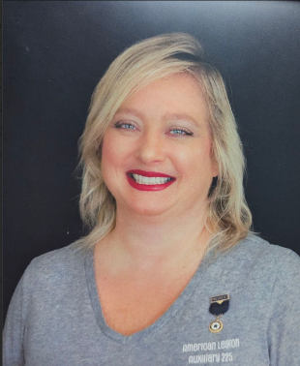
First Vice President Candidate
American Legion Auxiliary Unit 225 endorses Wendy Arend as Minnesota Third District First Vice President for the 2026-2027 year. Wendy Arend is a member of the American Legion Auxiliary Unit 225 in Forest Lake, MN. She is the current Chaplain and sits on the Standing Rules Committee for Unit 225 and is a past Unit President. She was the 2024-25 Minnesota Third District VA&R Chair. She is the 2025-26 Minnesota Third District National Security Chair and sits on the Constitution & Bylaws Committee for the Third District.
Wendy is eligible through her late husband, younger brother, and three adult children. In 2023, Wendy married Dave Arend, Sons of the American Legion National VA&R Committee Member and Detachment Membership Director. They reside in Forest Lake with their dogs, cat, and chickens. They often volunteer together at various events.
As a Death Investigator for the medical examiner’s office, Wendy responds to death scenes and determines the initial cause and manner of death. As a last responder, Wendy has seen the devastating effects of veteran suicide. Wendy encourages everyone in the Legion family to, “Be The One.”
Training and education are important in Wendy’s personal and professional life. She is a clinical psychology doctoral candidate; The focus of Wendy’s PhD dissertation is Veterans Treatment Courts and its impact on veterans. She also holds a Forensic Psychology MS, Criminal Offender Behavior BS, Homeland Security BS, Crime Scene Evidence AAS, and Homeland Security AAS.

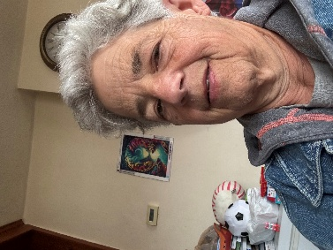
First Vice President Candidate
My Name is Sally Strasser, I am a 30 year member of the American Legion Auxiliary. I am eligible for membership through my late father Walter Zambiano. He was in the Army Air Cop. During WWII
At the Unit level I was president for 10 years also, I was secratary and held many chairmanship such as Girls State, Juniors, Poppy and assisted with many other chairmanships. At the district levelI was 2nd Vice Presdient, First Vice President and while I was first vice presdient, I was responsoble for membership which was 2005/2006. I was District President in 2006/2007 also, at the district level I have held other chairmanship such as; juniors and presently I am the Third District Histroy Chairman.
At Department level I have been on the Girls State Committee for 2 years, Auxiliary Emergency Fund, gift Shop for 2 years. I was part of the VA&R , Field Service and Commuity Service and also Histroy chairman.
I am asking for your supportas District 1st Vice Presisdent.

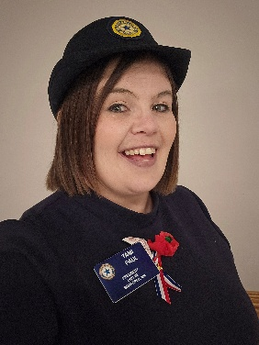
Second Vice President Candidate
Second Vice President Shakopee American Legion Auxiliary Unit 2 endorses Tami Paul for the position of Second Vice President of the Third District, American Legion Auxiliary Department of Minnesota.
Since joining Shakopee Unit 2 in May 2023, Tami has brought renewed energy and vision to our organization. In under a year, her fellow members recognized her leadership abilities, electing her as unit president. Tami’s dedication, leadership, and genuine commitment to service have made a lasting impact on our unit and community and the veterans.
Tami is currently serving on the Third District Executive Committee and has been appointed as the Third District Poppy Chairman for the 2025-2026 year. Her willingness to step into these roles demonstrates her ongoing commitment to the Auxiliary’s mission and her readiness to serve at higher levels.
As Unit 2 president, Tamis efforts have been recognized at both the state and national levels, including being named the 2025 Department of Minnesota Member of the Year and leading her unit on receiving the Northwestern National Leadership Award.
She has been involved in every unit poppy distribution, membership outreach event and organized a Sitcom Trivia Night and created engaging displays for the local library. She also took part in the American Legion 250 USA Family Challenge and helped assemble 250 basic back-to-school kits for local students.
Beyond her Auxiliary service, Tami is married to her Husband Adam, and they have 2 lovable dogs, Chip and Goober. She has devoted over two decades to early childhood education as an early childhood teacher. She brings creativity, inclusiveness, and a spirit of patriotism into her classroom—qualities that also define her work with the Auxiliary. She has attended leadership courses, conventions, and is currently taking a parliamentary course to better serve our organization.
Tami’s passion for honoring veterans is deeply personal, motivated by her desire to honor her late father, Korean War veteran Harlow LeRohl. Her hands-on leadership style, respect for tradition, and willingness to embrace new ideas, and listen to the past, have helped our unit thrive and brought our community closer together.
We believe Tami Paul’s blend of compassion, creativity, and dedication make her an outstanding choice for Second Vice President of the Third District. We offer our endorsement, confident she will serve the Third district with integrity, empathy, and vision.

Executive Committee Candidate

The Forest Lake American Legion Auxiliary Unit 225 endorses Sherri Hernandez-Neville for a second term on the MN District 3 Executive Committee for the 2026-2027 year.
Sherri Hernandez-Neville is a dedicated member of our Unit, having served as Member-at-Large and she is our membership chair. She is eligible through her grandfather, father, two uncles, and nephew. In 2024, Sherri married Glen Neville, who is the 1st and 3rd Vice Commander of the Detachment of the Sons of the American Legion. They reside in North Branch.
Sherri who works in the Bakery at Costco has supported our American Legion Family with many donations for events. She has also collected donations for Chemo/Radiation Kits for VA Hospitals and continues to collect for her project. Sherri has attended the National Convention for the last three years and plans to continue. She is actively involved in our Unit, volunteering for bake sales, funerals, poppies, and conventions. She is passionate about helping wherever she can and is interested in working with the Children and Youth Committee.
In 2025, Sherri attended Legion College, further enhancing her skills and dedication. Additionally, she has been involved with the Third District, serving one year on the Executive Committee.

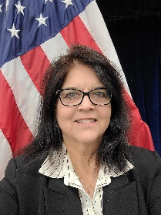
Executive Committee Candidate

The American Legion Auxiliary Unit #98 of St. Paul Park proudly endorses Jeorgia Cluckey for the Minnesota Third District Executive Board for the 2026–2027 term.
Jeorgia has been a dedicated member of Unit #98 since 2019. Her leadership and commitment to the mission of the Auxiliary are evident through her service as 2nd Vice President, three consecutive terms as Unit President, is a current member of the Executive Board and her roles as Chair for Public Relations, Leadership, Poppies and Past President Parley. At the district level, she served as the 2024–2025 Third District Public Relations Chair and currently holds the position of 2025–2026 Membership Chair.
Jeorgia’s eligibility for membership is through her grandfather who served in WWII and the Army Reserves. Her connection to the Auxiliary runs deep—her mother was a member in the 1970s in St. Croix Falls, WI, and Jeorgia herself volunteered at the Post for many years alongside her sisters, even before officially joining.
Professionally, Jeorgia brings over 18 years of experience at UnitedHealthcare, where she currently serves as a Regulatory Affairs Consultant. Her organizational skills, strategic thinking, and dedication to service have greatly benefited Unit #98, where she remains actively involved in volunteering, event planning, fundraising, and program leadership.
Jeorgia resides in South St. Paul with her husband, Clint. Her passion for the Auxiliary and her proven leadership makes her an outstanding candidate for the Third District Executive Board.
We wholeheartedly support her candidacy and are confident she will continue to serve with integrity, enthusiasm, and excellence.

